**CONTAINER PUBLISHING:**

For the purpose of scanning the container in one of the later stages of the pipeline, first we have to publish the image with the projects inside of them, creating it with a custom DockerFile with the following code:

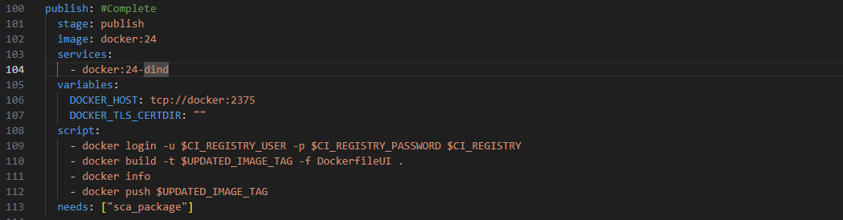

The image created that we are gonna publish is based on the following DockerFile:  
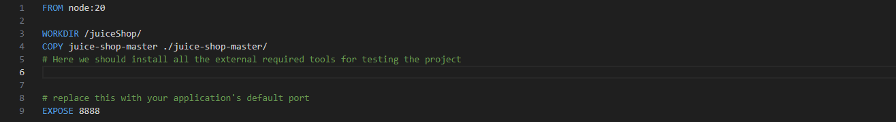

* From the version of node that does not conflict with the Project’s dependencies
* Copies the Project inside the image
* Exposes the port 8888, often used by node.js projects